Bell Ringer: Scientific Variables Name: Date:
Problem: Does the colour of light affect the size of strawberries?
An experiment is set up to test the effect of changing the colour of light on the size of strawberries. Five flowering strawberry plants (fruit grows from the ovaries of pollinated flowers) are placed in pots of equal size, given the same amount of soil, water and fertilizer. Each plant is placed under a different coloured light as shown below. After two months, the strawberries are from each plant are collected and measured to determine their size.
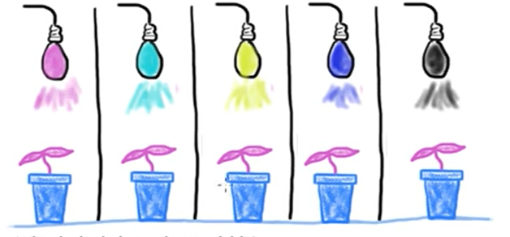
Light Colours: Red Green Yellow Blue White (contains all colours)

- Identify all of the following in this experiment:
A) Independent variable: B) Dependent Variable
C) Experimental Group D) Control group:
E) Control variable(s):
- Write a hypothesis for your prediction: (If … then … )

Bell Ringer: Scientific Variables Name: Date:
Problem: Does the colour of light affect the size of strawberries?
An experiment is set up to test the effect of changing the colour of light on the size of strawberries. Five flowering strawberry plants (fruit grows from the ovaries of pollinated flowers) are placed in pots of equal size, given the same amount of soil, water and fertilizer. Each plant is placed under a different coloured light as shown below. After two months, the strawberries are from each plant are collected and measured to determine their size.
Light Colours: Red Green Yellow Blue White (contains all colours)

- Identify all of the following in this experiment:
A) Independent variable: B) Dependent Variable
C) Experimental Group D) Control group:
E) Control variable(s):
- Write a hypothesis for your prediction: (If … then … )

