Protein Synthesis Analogy
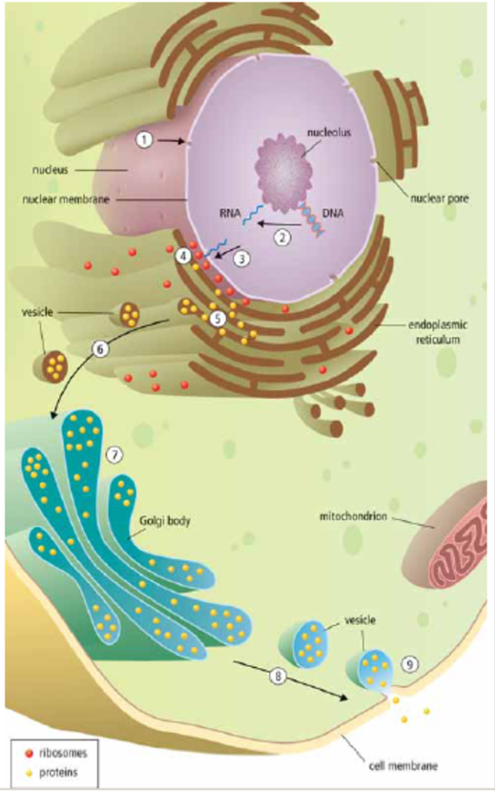
Job #1: Label and colour the ribosomes and proteins (Think: Which is the cell producing to send out of the cell? Which is going to be going inside vesicles, Golgi body, etc?)
Introduction:
Your saliva plays a vital role in chemically digesting your food. When you put a cracker in your mouth and don't chew it, it will dissolve due to enzymes (proteins) in your saliva breaking down the cracker. The name of the enzyme in saliva is called salivary amylase. How do the cells in your mouth make this enzyme and not some other enzyme by accident? After all, the cells in your mouth have all the DNA to make every protein in you! What is the chain of events that causes a cell in your mouth to produce the enzyme salivary amylase?
Analogy:
Apple is a big company that has been producing computers and phone for many years. They have thousands and thousands of products that have been produced over the years. When they receive an order for a particular phone, how does that specific phone get produced and sent to the right place?

- The nucleus of a cell in the salivary glands of your mouth receives a chemical signal in the form of a hormone which signals it to begin making a specific protein - salivary amylase protein.

You phone Apple and order (chemical signal) the new Iphone 12 (salivary amylase protein).
- The information to produce everything in the body is stored in DNA which is kept in the nucleus of every cell. The DNA information to build this specific protein (salivary amylase protein) is stored in a small section of the DNA called a gene. This gene is copied from the HUGE DNA into a new SMALL molecule called RNA. The DNA is left completely unchanged during this process and stays in the nucleus.
Apple has the plans to produce every Apple product ever stored in huge database book (DNA). The database book is kept safe in Apple headquarters (nucleus). The instructions to build the Iphone 12 (salivary amylase protein) are kept in one page of the database book (gene). The instructions to build the Iphone 12 are photo copied from the database book onto a new piece of paper (RNA). The database book (DNA) is left unchanged and is still kept in headquarters (nucleus).
- The RNA now contains information (the instructions) to produce one protein (salivary amylase). This RNA message is small and can leave the nucleus through a nuclear pore. DNA is too big and too important to leave the nucleus!
The paper (RNA) now has the instructions to produce one product, the Iphone 12 (salivary amylase protein). This paper message (RNA) is small and is allowed to leave the headquarters (nucleus) through the security door (nuclear pore). The database book is too big and too important to leave headquarters!
- The RNA message is delivered to the ribosome embedded in the rough endoplasmic reticulum. At the ribosome, a protein building factory, the information stored in the RNA is read like a recipe to produce the protein (salivary amylase).
The paper with Iphone 12 instructions (RNA) is delivered to the factory (ribosomes) connected to conveyor belts (endoplasmic reticulum). The Iphone 12 instructions and read by the factory which produces the Iphone 12 (salivary amylase protein)
- The manufactured protein enters the ER and travels through a network of channels until it reaches the end.
The Iphone 12 (protein) is placed on the conveyor belt (ER) where it travels to where the trucks are waiting.
- A vesicle filled with the protein forms off the end of the ER. The vesicle is 'walked' along the cytoskeleton until it reaches the Golgi body.
A truck (vesicle) loads the Iphone 12 and drives it the distribution center (Golgi body).
- The Golgi completes the protein by folding it and attaching other parts (such as sugars, fats, or other proteins) to it.
The distribution center (Golgi body) puts the finishing touches on the Iphone (protein) such as packaging, instructions, headphones, stickers etc
- The completed protein is put into a new vesicle and marked for transport out of the cell. The vesicle is moved along the cytoskeleton until it reaches the cell membrane. The completed protein is released out of the cell into your mouth to digest the cracker.
The distribution center loads the completed phone into a shipping container (vesicle) and places the proper address on the container, then sends the container to the fence surrounding the Apple company (cell membrane). The Iphone is delivered to you.

